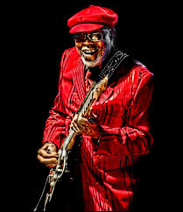
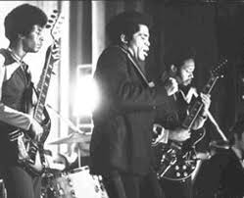
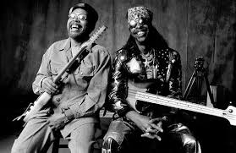

Phelps “Catfish” Collins
ON AUGUST 6, 2010 PHELPS COLLINS, THE GUITARIST KNOWN worldwide as “Catfish”, succumbed to cancer in his hometown of Cincinnati. As an inspiration to younger brother, bass icon Bootsy Collins, Catfish was a major catalyst in the development of funk. And as the man behind the addictive guitar lines that electrified a wealth of classics from... James Brown, Parliament/Funkadelic and Bootsy’s Rubber Band, he was funk’s quintessential rhythm guitarist. Catfish was already a renowned guitarist in the Midwest when he inspired a young Bootsy to put bass strings on an old guitar. By 1968 they were the Pacemakers, along with drummers Frankie “Kash” Waddy and Don “Tiger” Martin. Not two years later, they were the key musicians in the J.B.s, the band behind James Brown, then one of the world’s biggest stars. Catfish’s relentless, infectious rhythm guitar work was a defining characteristic of many of Brown’s most successful tunes, and spiraled into new realms of complexity and range as a member of Parliament/Funkadelic after the trio left Brown’s band in 1971. The lion’s share of funk’s most memorable guitar licks came from Catfish, and his musical contributions played a significant part in shaping the genre, as well as the hip-hop music that soon followed. Two songs featuring Catfish – James Brown’s “Get Up (I Feel Like Being a) Sex Machine” and Parliament’s “Flash Light” – are listed in Rolling Stone’s “500 Greatest Songs Of All Time”. “Catfish was my brother, my father and most of all my best friend,” Bootsy Collins said. “Catfish was a different kind of human being, he only wanted love and peace in every situation. To me Catfish was the one that inspired me to be at one with all that is, which is everybody and everything that was created by the One. Catfish taught me that to be love meant more than just to talk about it. Sure we all may have a great interpretation of love in our everyday language that people understand, but even a child that don't understand a word knows when he is in the presence of love with no words mentioned, that is who the Catfish was and still is. He was that word that did not have to speak in order for you to understand the depth of his being, his soul, his peace and joy. “My world will never be the same without him. Be happy for him, he certainly is now and always has been the happiest young fella I ever met on this planet. Catfish is survived by his sister Brenda, Bootsy, his two kids Carmen and Phelps the 3rd, nephews, nieces, cousins, aunts and uncles, friends and fans. Thank you all for being a part of ‘The Catfish Life’; he was truly an amazing gentleman!”
Bootsy Collins for Funkateer Nation!!!

https://www.youtube.com/watch?v=OZT9ODyB4hc

